Form 1212 and SAP Workflow

This construction bulletin addresses project acceptance and completion of the Form 1212 with the SAP system on all projects that have been constructed.

History:

When SAP was rolled out, the Form 1212 workflow was initiated when the project was set to TECO (Technically Complete). The project was meant to be set to TECO when construction was completed. The Form 1212 could not be created unless the project was set to TECO. Additionally, the Form 1212 workflow was started for all projects set to TECO even if a Form 1212 was not required. Some projects had to be set to TECO more than once, creating more than one Form 1212 for a project and creating duplicate workflows.

New Process:

Below is the guidance for the new process to create a Form 1212 in SAP for projects that have construction completed. It addresses what needs to be done to close projects where a Form 1212 is not needed. The Form 1212 is commonly required on each construction project even if it is funded with all state funds. Consult the Region Finals Engineer for the region's requirement for all state funded projects.

- Once a project is accepted in construction as complete, either by CDOT or the Local Agency, the Form 1212 workflow should be started in SAP. Starting the Form 1212 workflow can be done in one of two ways, depending on the type of project.

  - For CDOT administered projects, the Form 1212 workflow is triggered automatically when the Project Acceptance Date is populated within Site Manager (it will be filled in during the night but not immediately after input). This date is automatically brought over to the SAP system and populates the same field in the Project Manager Custom Tab in transaction CJ20N. Please refer to the portion of the SAP Project Manager tab screen shot below:

This date will be automatically populated through Site Manager. It can only be populated through this method for CDOT Administered construction projects. Note the box is grayed out or blue in color which means that it cannot be completed by the user.

  - For Local Agency Projects and Non-Engineering Capital Projects: The Form 1212 workflow is triggered when the assigned Project Manager populates the Project Acceptance Date within the Project Manager Custom Tab in transaction CJ20N. These project types do not manage Construction activities through Site Manager and the acceptance date must be entered manually. Please refer to the portion of the SAP Project Manager tab screen shot below:

For local agency and non-engineering capital projects, Project Managers must manually populate the date in Order to start the Form 1212 workflow. Note the fieldis white meaning it can be changed by the user.

- Once the Form 1212 Workflow has been started,, a form 1212 workflow item and outlook email message will be sent to all Resident Engineers within the Project’s region. The Resident Engineer managing the project should open this workflow through transaction SBWP to save the workflow or to complete the Form 1212. Please refer to the screen shot below:

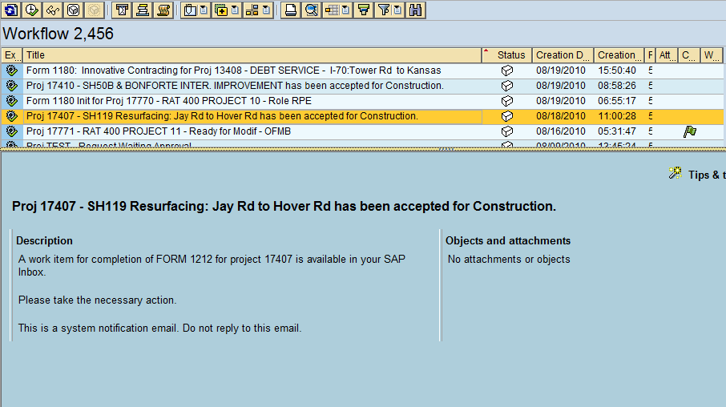

  - NOTE: The SAP development team is currently developing a change to all workflows that would limit the size of the audience of Project Systems workflows. For this workflow only the Resident Engineer responsible for the project would receive the workflow item in SAP and receive the Outlook email message.

- Upon opening the workflow message, the Form 1212 for the project will be ready for modification.

  - The top section of the form has two fields that need to be completed by the Resident Engineer (Contractor’s Name; Inspection Date). All other fields will be automatically populated using existing information within SAP. The Federal Oversight radio button is automatically selected based on the project information in SAP, but can be changed if necessary. Please refer to the screen shot below:
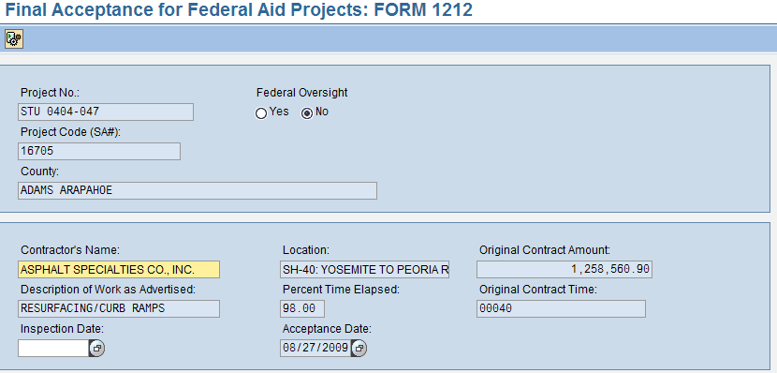

- The bottom section of the form is the checklist of activities that should be complete as part of project acceptance. All must be checked before submitting the form. The Resident Engineer can select whether the project included a major bridge or not. If a major bridge is included in the project, the Staff Bridge inspection checkbox must be selected before submitting the form. Please refer to the screen shot below:
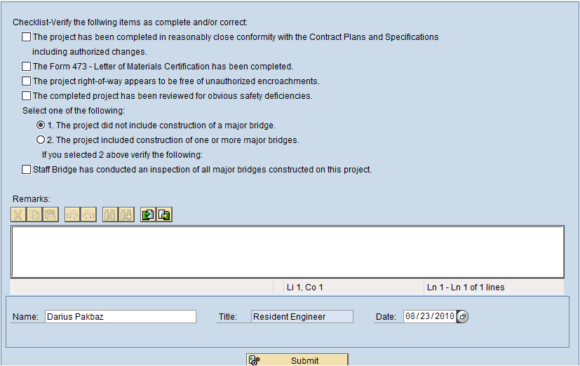

- The Resident Engineer and date fields at the bottom of the form are automatically populated with the user initiating the workflow and the current date. These can be changed if needed.
- Click the “Submit” button to complete the Form 1212.

- If the Resident Engineer is not ready to complete the Form 1212 when he receives the workflow, then the workflow should be reserved with that Resident Engineer. Open the workflow item; then close it without completing it. It will show that this workflow is only in that Resident Engineer’s SAP business workplace. See screen shot below:

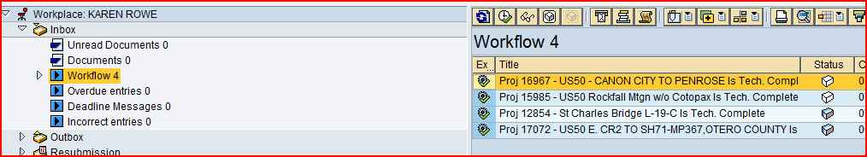

- The workflows only in the Resident Engineer’s workplace show a blue and white box under status. This is referred to as “reserving the workflow item.”
- The workflows in all the Region’s Resident Engineers' workplaces show a white only box.
- The Resident Engineer can come back to this reserved Form 1212 workflow when he is ready to complete it.
- If you want to unreserve a Form 1212 workflow and put it back in all the Region’s workplaces, highlight the workflow and then press the button.

- After the submit button is hit, the workflow is automatically completed and an Outlook message is sent to all Resident Engineers indicating that the Form 1212 is complete. Attached is a pdf copy of the completed form. The Resident Engineer should print the pdf copy, sign it and send the form with other project closure paperwork to the Region Finals Engineer. Please refer to the example below:

From: Workflow System [mailto:WF-BATCH@dot.state.co.us]
Sent: Friday, August 20, 2010 2:45 PM
To: XXXXX
Subject: Notification: Form 1212 Complete for Proj 14959

The constructed project has been accepted and the Form 1212 is attached for review. The Resident Engineer should print and sign the form and distribute the signed form to the Regions Final Engineer.

Project Name: SH 58/ 44TH AVE BRIDGE REPLACE.

Program Engineer/Branch Manager: JAMES BEMELEN.
Resident Engineer/Section Head: PAUL JESAITIS.
Project Manager/Pre-Constr. Engineer: CYNTHIA BAILEY.
ProjectEngineer/Constr. Engineer: JAMES MARTIN.

This is a system notification email. Do not reply to this email.

  - NOTE: The SAP development team is currently developing a change to all workflows that would limit the size of the audience of Project Systems workflows. For this workflow only the Resident Engineer and Finals Engineer responsible for the project would receive the Outlook email message.

- This completes the Form 1212 process. The project can be set to TECO and the business office can start project closure activities. It is up to the Region who will set the project to TECO prior to closure. It is recommended that the Business office set the project to TECO after the project is de-budgeted. The project will have to be set to TECO prior to project closure. Setting the project to TECO will no longer start the 1212 workflow.

For projects that do not require the Form 1212 to be completed, the workflow can be bypassed and the business office can start project closure activities. These types of projects include design-only projects, property projects, DTD projects, maintenance projects, withdrawn projects, or any other projects that do not have a Construction phase.

  - For these projects, the Business Manager or designee can mark the Form 1212 status in CJ20N for the project and save the project. Once this status is set, the business office can set the TECO status and begin project closure activities and the Form 950 workflow. Please refer to the screen shots below:

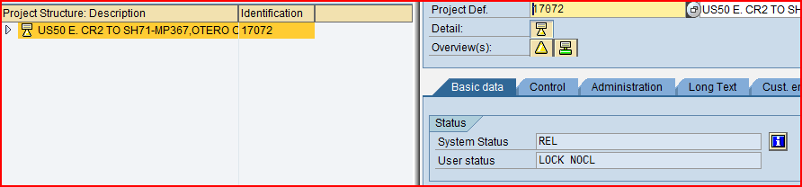

Hit the blue “I” button at the top level of the project. Then the following screen will appear.

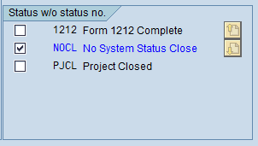

Frequently Asked Questions:

What do I do if I lost the Form 1212 workflow?

There is now a workflow report available that will allow anyone to see where any workflow is located. It may be in another RE’s SAP workplace and this report will indicate the location. The report is located in the Portal under the Report tab, then under Project Systems. If help is needed with the report, contact your region Super User or the SAP Project Systems support team.

What do I do if I want to run the Form 1212 workflow again?

There is no way in the system to easily re-run a Form 1212 workflow that has already been completed. If the Form 1212 that was created is needed or if the workflow needs to be restarted, the SAP Project systems support team will need to be contacted. Please contact the SAP Project Systems Business process experts who are currently Tony Bemelen and Darius Pakbaz.

Why do I need to do the Form 1212 in SAP when there is a form for it?

The information pulled from SAP for the Form 1212 will be consistent for all projects. It also assures that the Form 1212 was completed for a project that was constructed.

Any questions regarding this process can be referred to your local power user, regional super user or the SAP Project Systems support team at CDOT Headquarters.

Contact:

Darius Pakbaz, Project Systems BPX

